Lab 19: Password Cracking

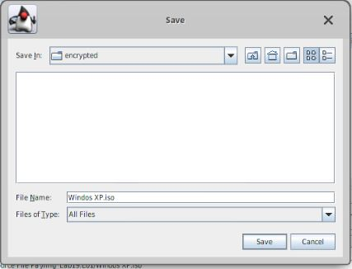

1.19 - Save screen

2.4 - Found password

3.11 - Extract here

4.4 - Word list

4.6 - Successful file open